9/23/2022

PF lab Assignment

Lab#04

Abdullah Shafiq

22k-4489

**Task 01**

Ahmed answered 30% of the questions correctly. The test contained a total of 80 questions. Write a program to tell how many questions did Ahmed answer correctly.

Program & Output:

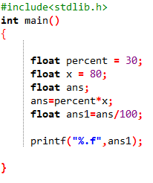



**Task 02**

Write a program to find the sum of two integers without using ‘+’ operator.

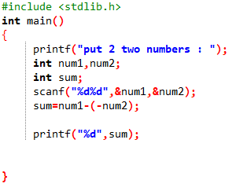Program & Output:



**Task 03**

Take relevant inputs from the user according to formula and calculate the area of:

1. Circle

2. Square

3. Rectangle

Program & Output:

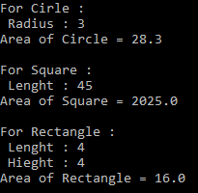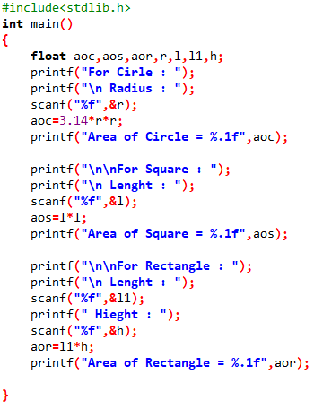

**Task 04**

Write a program to take a number as user input and the check the following conditions

1. Number is greater than 50

2. Number is less than 50

3. Number is equal to fifty

Program & Output:

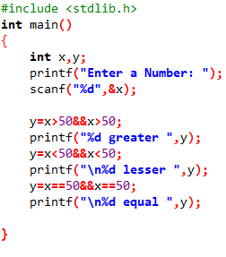

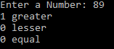

**Task 05**

A students’ report card needs to be developed. Write a program that takes marks of 5 subjects each of 100 marks. The subjects are:

1. Math

2. Urdu

3. English

4. Islamiyah

5. Pakistan Studies

Program & Output:

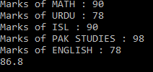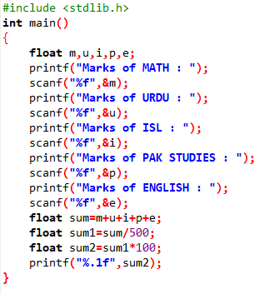

**Task 06**

Write a C program that performs the following tasks:

1. Take hours from user, convert it into minutes and seconds.

2. Take years from user, convert it into weeks and days.

Program & Output:

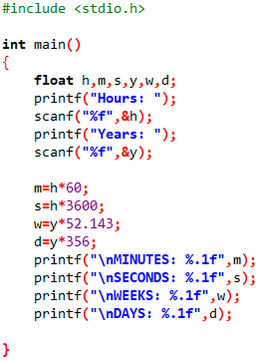

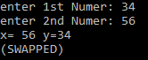

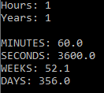

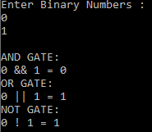

**Task 07**

Write a program to swap 2 numbers using a third variable.

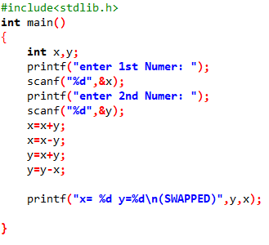Program & Output:

**Task 08**

Create a two-input truth table of AND gate, OR gate and Not gate using logical operators.

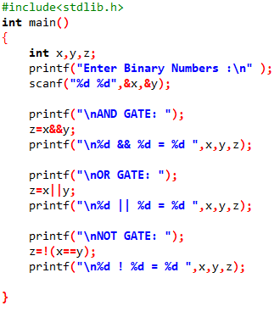Program & Output:

**Task 09**

Write a C program to Find out distance, coordinates of midpoint using distance formula.

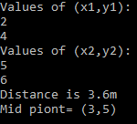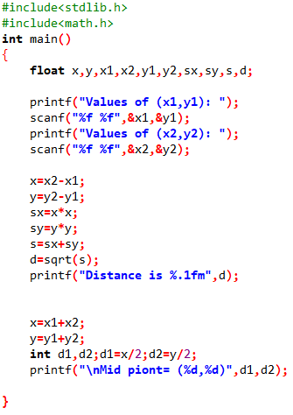Program & Output:

**Task 10**

Write a C program to Find the Roots of a Quadratic Equation. Take user input values of b, a, c:

Program & Output:

